

**Department of Computer Science and Engineering**

**Programme Name: B.Tech in Computer Science and Engineering (AI)**

**Semester V**

**Course Name: Computer Networks Lab**

**Course Code: PCC-CSM592**

**Experiment 4**

**Aim:** Implementing distance vector and link state routing protocols - EIGRP.

In dynamic routing Protocol, if the destination is unreachable then another entry, in the routing table, to the same destination can be used. One of the routing protocols is EIGRP.

|  |  |  |  |
| --- | --- | --- | --- |
| S.No. | Device | Model Name | Qty. |
| 1. | PC | - | 2 |
| 2. | switch | 2950-24 | 2 |
| 3. | router |  | 2 |

|  |  |  |  |
| --- | --- | --- | --- |
| S. No. | Device | IPv4 Address | Device Gateway |
| 1 | PC1 | 10.0.0.2 | 10.0.0.1 |
| 2 | PC2 | 20.0.0.2 | 20.0.0.1 |

|  |  |  |  |
| --- | --- | --- | --- |
| S. No. | Device | Interface | IPv4 Address |
| 1 | router1 | FastEthernate0/0 | 10.0.0.1 |
| Serial2/0 | 30.0.0.1 |
| 2 | Router2 | FastEthernate0/0 | 20.0.0.1 |
|  | Serial2/0 | 30.0.0.2 |

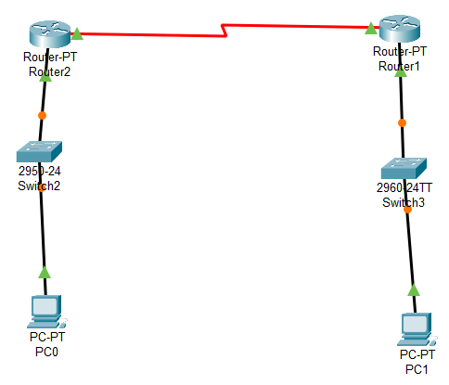

CLI command

Router(config)#router eigrp 10  
Router(config-router)#network 10.0.0.0 255.0.0.0  
Router(config-router)#network 30.0.0.0 255.0.0.0

Router(config)#router eigrp 10  
Router(config-router)#network 10.0.0.0 255.0.0.0

Router(config-router)#network 30.0.0.0 255.0.0.0

Output:

C:\>ping 20.0.0.2

Pinging 20.0.0.2 with 32 bytes of data:

Reply from 20.0.0.2: bytes=32 time=17ms TTL=126

Reply from 20.0.0.2: bytes=32 time=19ms TTL=126

Reply from 20.0.0.2: bytes=32 time=2ms TTL=126

Reply from 20.0.0.2: bytes=32 time=12ms TTL=126

Ping statistics for 20.0.0.2:

Packets: Sent = 4, Received = 4, Lost = 0 (0% loss),

Approximate round trip times in milli-seconds:

Minimum = 2ms, Maximum = 19ms, Average = 12ms